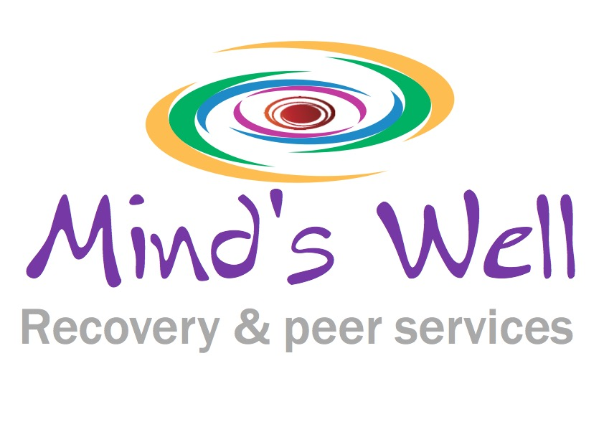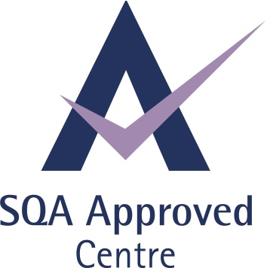

Peer Mental Health Educator (PMHE)
Tutor
Job Description

Overview
Knowing that mental health impacts people’s lives, Mind’s Well role is to facilitate the adoption and maintenance of health enhancing behaviours among the general public through education.

Peer Mental Health Educators contribute to this mission by providing accurate & current health information to mental ill-health sufferers, families/friends, community at large and professionals.

Peer Mental Health Educators will use a variety of delivery strategies including:
- Interactive displays
- Social media (i.e., facebook, twitter, blog, & monthly e-newsletter)
- Workshop presentations
- Assisting in the design and development of health promotion materials.
- Disseminating information about mental health resources in the community.

General information

Salary info: £17,169 to £23,945 pro rata
Job Type: Part-time 16 hours per week
Duration: Six months initially, starting on 1st June 2020
Location Home based
Responsible to: Maria Naranjo

Job Duties & Responsibilities

- To be aware and promote The Mind’s Well RC values and quality standards.
- Attend and actively participate in group learning sessions and team meetings.
- Organise materials, IT and feedback forms to take to training sessions and workshops.
- Full responsibility to deliver one day workshops on the subject of self-harm that cover theory, practice and what to do about it.
- Evaluate and redesign learning materials in response to feedback from participants and The Mind’s Well RC management committee.
- Role model Peer Support principles of mutuality, empowerment, empathy and strengths based approach.
- Collect feedback forms from participants in workshops, training sessions and awareness raising sessions.
- Act as guest or paid speaker on behalf of The Mind’s Well RC in Conferences, Planning and Strategic meetings and any such events as required.
- Facilitate PR opportunities for The Mind’s Well.
- Co-deliver our current support online programmes.
- Any other duties that the Mind’s Well RC management team consider necessary and appropriate.
- Maintain a working knowledge about mental health, self-harm, recovery and peer support by researching, attending training events, peer support networks etc.

Person specification

 | Essential | Desirable

QUALIFICATIONS:
Training for trainers on self-harm
Completion of the PDA in Mental Health Peer work or relevant course in peer work
Applied Suicide Intervention Skills Training

EXPERIENCE:
To have a lived experience of mental health, using self-harming behaviours to cope and a recovering meaningful life.
To have experience of being in a supportive and enabling role
Understanding of the issues and concerns of people accessing mental health services

Understanding of Mental Health Issues

Co facilitation of groups/ courses

Experience of researching, reviewing and evaluation

SKILLS:

Ability to motivate others
Good interpersonal skills
Good written and verbal communication skills
Ability to work independently
Computer literate
Ability to work as part of an integrated team
Ability to maintain confidential records and statistical information on service use for the purpose of evaluation
Ability and willingness to share personal story of self management and recovery in a professional manner

PERSONAL TRAITS:

Self motivated
Able to use initiative
Enthusiastic
Enjoys being with people
Able to work flexible hours including evening and or weekend in required

.

